My Dental Routine

[insert picture of ______ brushing his/her teeth]

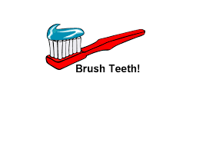
To keep my teeth healthy and strong I need to brush them every morning and every night.

First I use my toothbrush and toothpaste and brush front and back for at least 2 minutes.

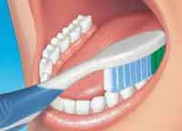
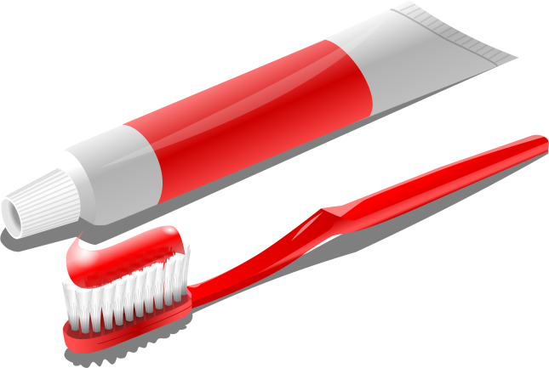

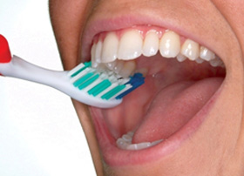

When I am finished brushing I need to rinse my mouth out with water and put my toothbrush away.

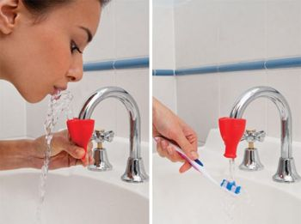

I then need to floss my teeth.

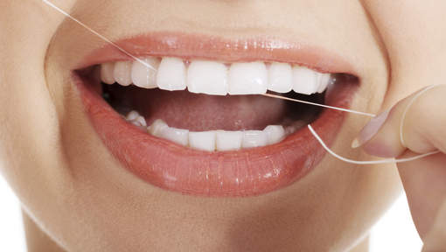

This helps get all the food out from between my teeth.

Sometimes I might not feel like brushing my teeth.

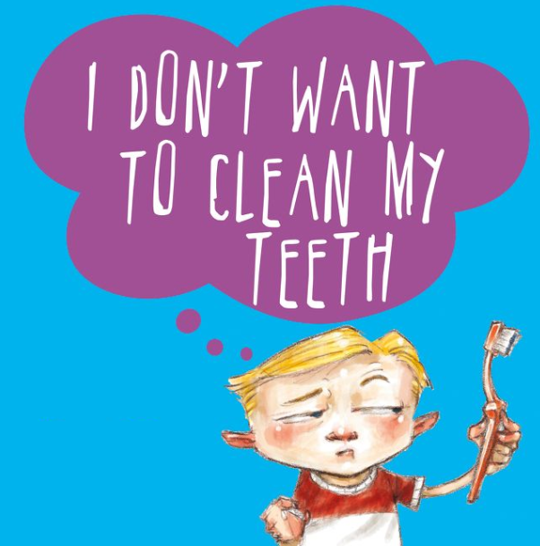

I will need someone to remind me that everyone brushes their teeth.

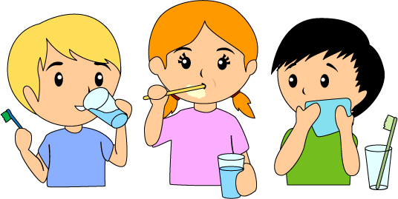

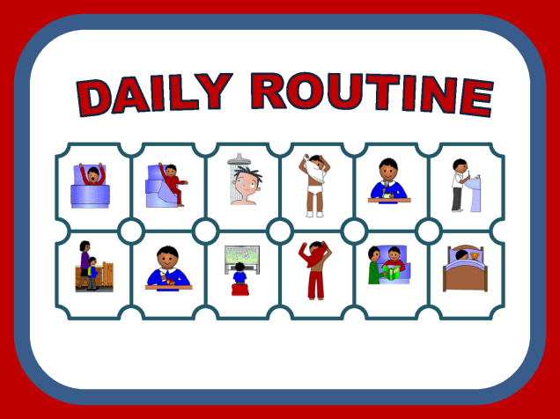
I might like to check my routine and put a tick next to the task when it is completed. This makes me happy!

If I don't brush my teeth I will have bad breath. I don't like this.

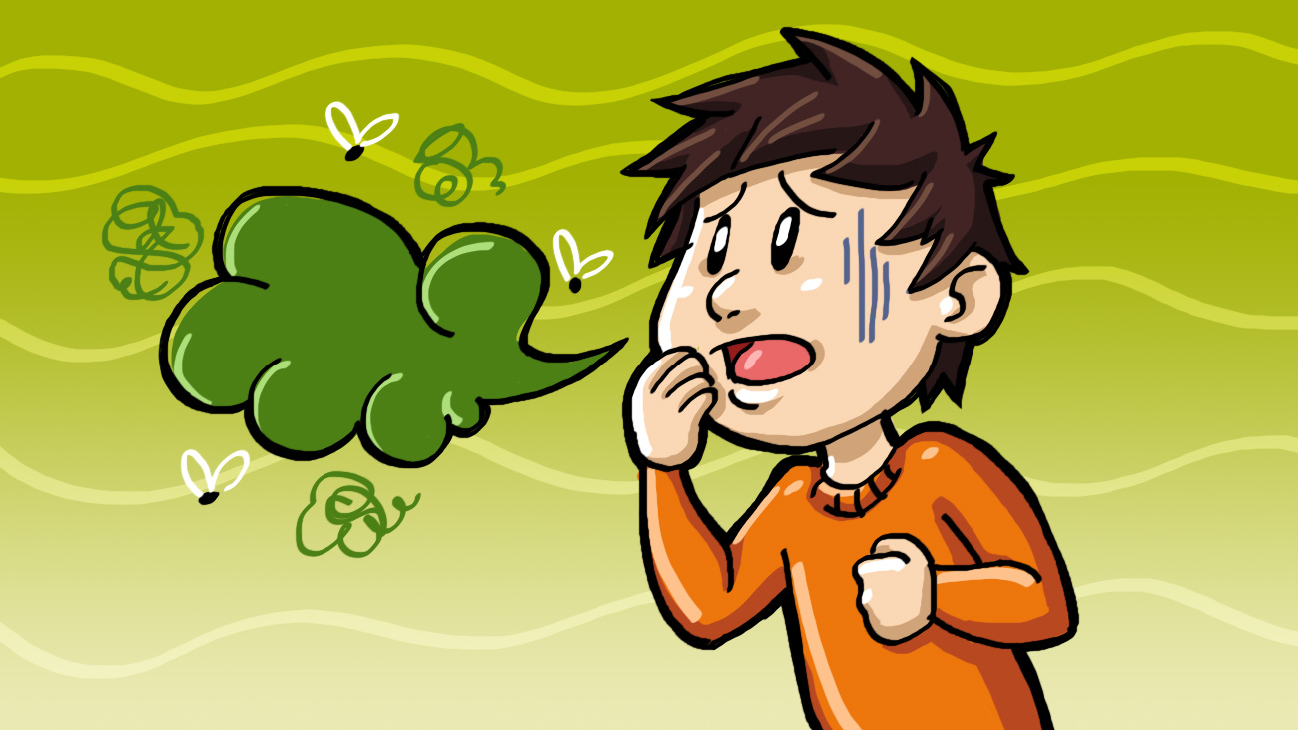

My teeth will start to feel furry. They won't look nice and white if I don't look after them.
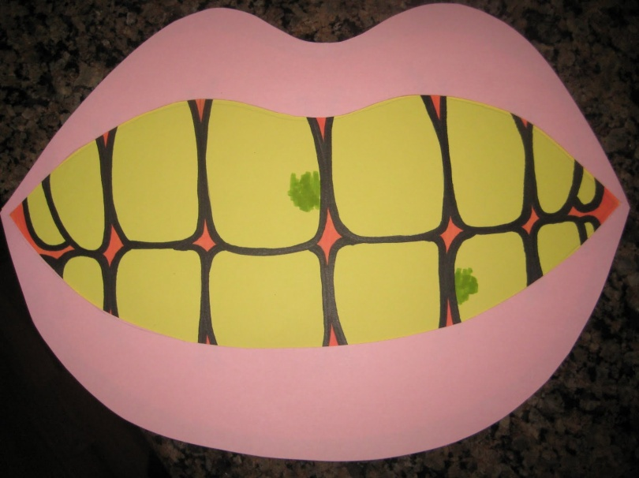

I might have some problems with my teeth such as weakening, holes or enamel erosion.

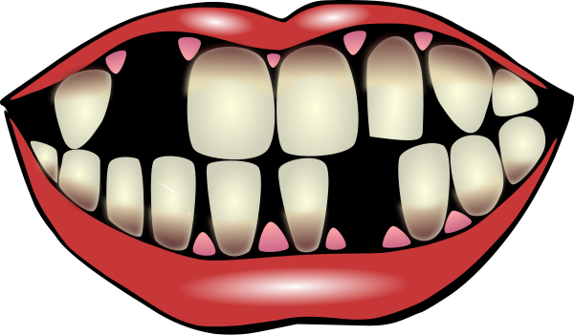
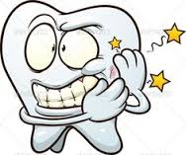

This may be from my saliva or teeth grinding. The dentist will give me a special mouth wash to help.
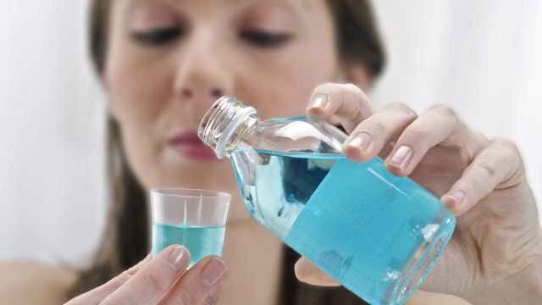

Drinking water during the day helps to keep my mouth and teeth clean as well.
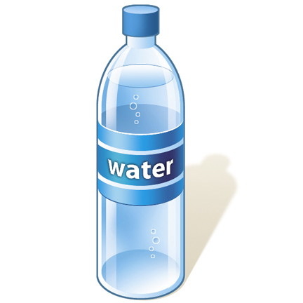
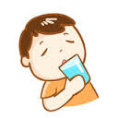

I like looking after my teeth and having a beautiful smile

