When I Feel Angry

[insert photo]

Sometimes I feel angry

It's ok to feel angry sometimes,
everyone gets angry at times.

I might get angry when.......
I think something is unfair Or when there is a change in routine

Or when people don't Or when I am told
listen to me to do something I
don’t want to do

When I am angry I might…..
Start to feel hot and Wave my arms around
my cheeks go red

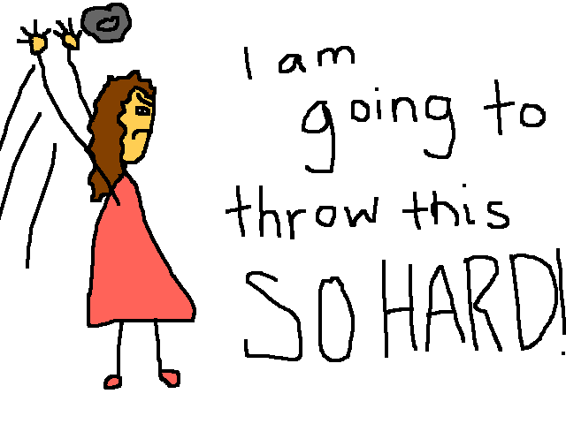
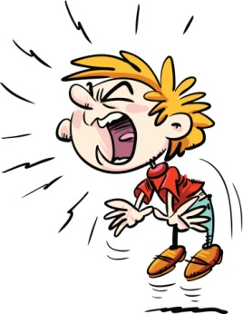
Start to talk loudly and Throw things around
pace around. the house

When I feel angry there are things I can do to
calm down….

Take 10 deep breaths, close my eyes and count to 10

1, 2, 3, 4, 5, 6, 7, 8, 9, 10

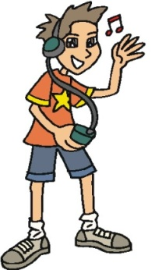
Go to my room and listen to my favourite
music

Go to my calm down spot
[insert calm down spot]

Go and hit my totem tennis ball outside.

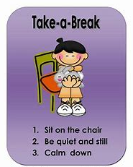
Sometimes it is good to take a break from what I am doing

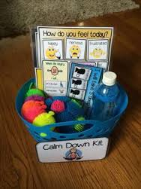

and use my calm down kit .

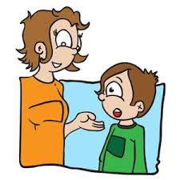
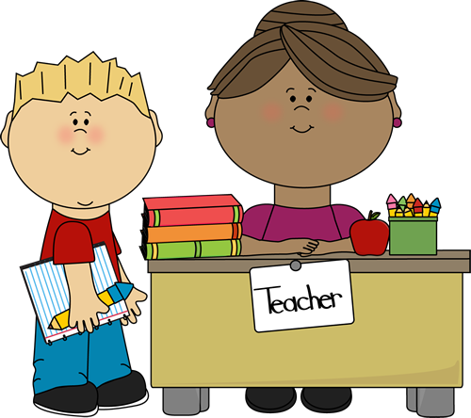
I should always talk to an adult (mum, dad, teachers, carers) when I start to feel angry

They will remind me of the things that help me calm down
I will feel better after talking and calming down

