I am going to a party

[insert photo]

I love getting invited to parties

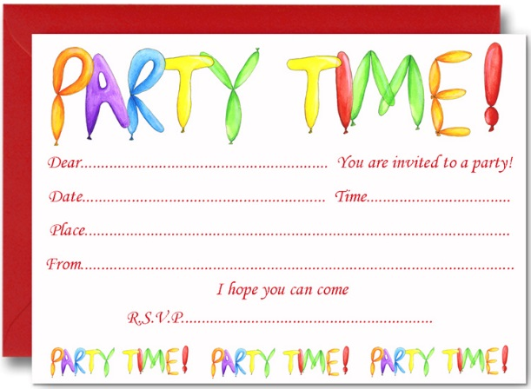
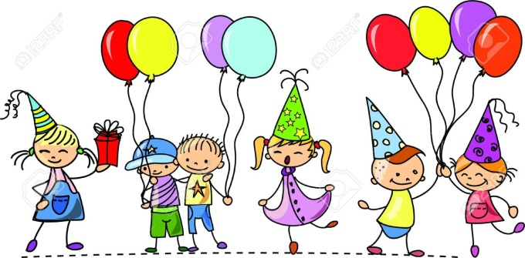

Parties are lots of fun and I love shopping for
nice gifts

Parties can be hard for me because I know it is not good for me to eat the same food that other people my age might have

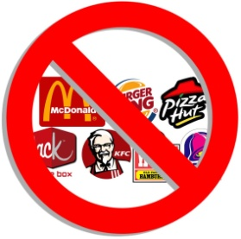

I know that having PWS means I have trouble stopping myself from eating and drinking too much

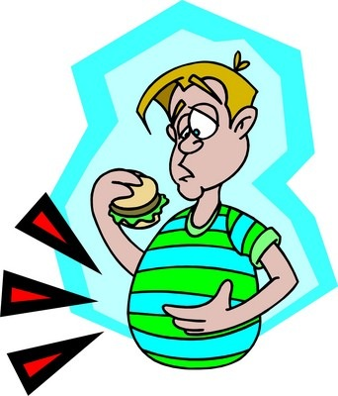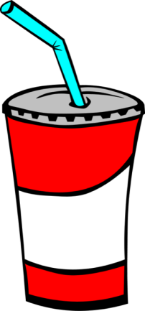

Having PWS is hard sometimes. I know I need some help from my family and friends to keep healthy
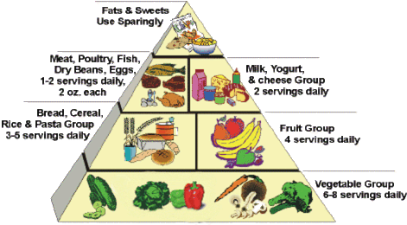

My [Mum] might want to talk to my friends’ [Mum] before the party, to discuss coming with me and what food will be there

It is important for me to know where the party is and what food will be served

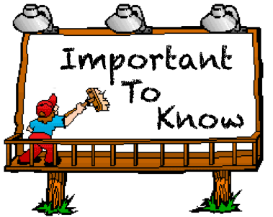

This helps plan my weekly food so that I can still enjoy some special party food

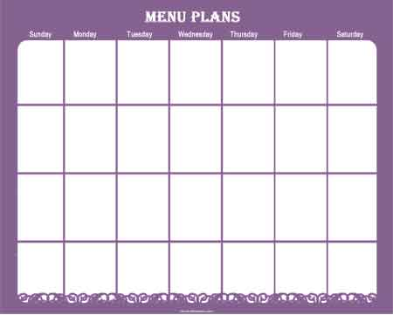
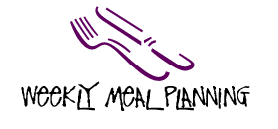

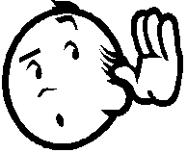
[Mum] will come with me to the party. It is important that I listen to what [Mum] says

I can have one small plate of special party food

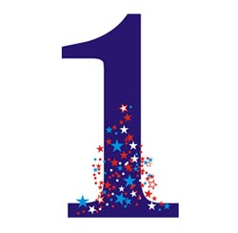
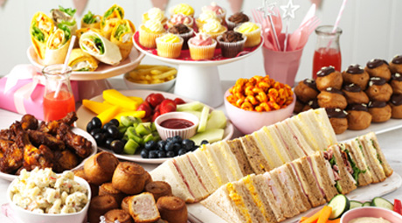

If I try to have more, [Mum] will say it is time to go.
This would make me sad

This will be a fun day for me, this makes me happy!

