GOING TO THE DOCTOR /
PWS CLINIC
[Replace images with real photos where possible
(particular people, set items and places etc)]

I have different doctors in my life who I like to visit. They help me stay healthy and well.
[insert name] - PWS clinic
[insert name] - Dentist
[insert name] - Psychologist
[insert name] – Dietician

Today I am seeing [insert name] at the PWS clinic at [insert time].
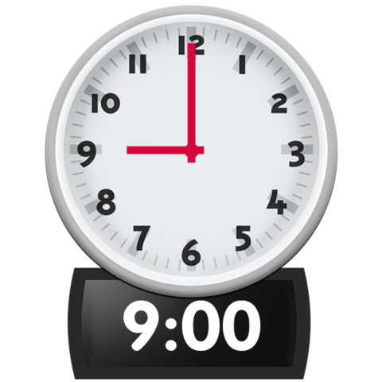
Mum and I drive to the [insert Hospital/place] to see [insert name].

My appointment will take about [insert timeframe].
Sometimes appointments take longer or [insert name] may be running late. I have my favourite book to read if I have to wait.

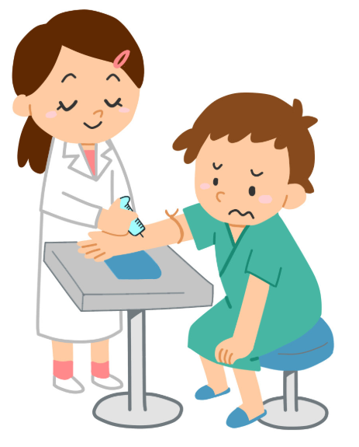
[insert name] will take a blood test, if I haven't had one recently.

Sometimes I don't know when I am not well, or may not feel if something is wrong so [insert name] might ask for me to go for some scans and x-rays just to make sure everything is perfect.

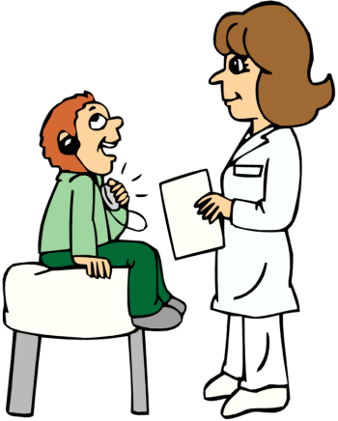
We will talk about how I am feeling, how school is going and how my friends are.

[insert name] will check my weight.

[insert name] will ask mum and I about what foods I have been eating.

[insert name] will check my skin for any sores and bruises.

[insert name] will ask mum some questions about me too. I don't like to be talked about unless I can stay in the room.
They might talk about my exercise, medication, diet, behaviour and school.
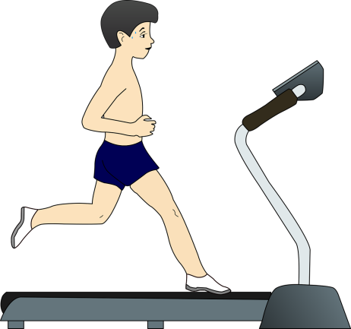

When I finish seeing [insert name], Mum and I will go and have a [small treat] and talk about my appointment.

