GROCERY SHOPPING DAY

*Where possible we recommend using real photos, i.e. of specific people or places mentioned

I like going out to the shops and helping with the shopping.

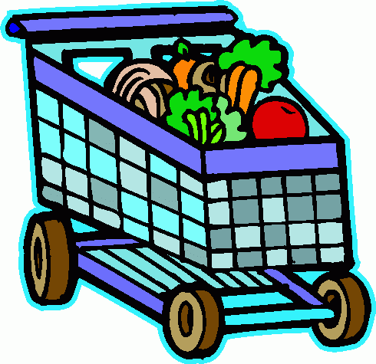

I go shopping at [insert name of grocer and place].

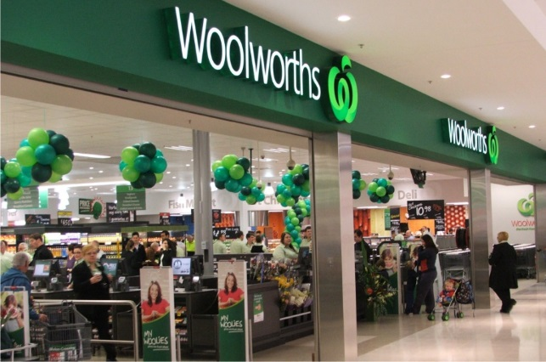

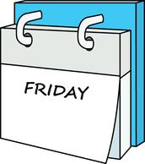
It is my turn to help with shopping on
[insert day, morning/afternoon or evening].

I like to help with planning meals and the
shopping lists.

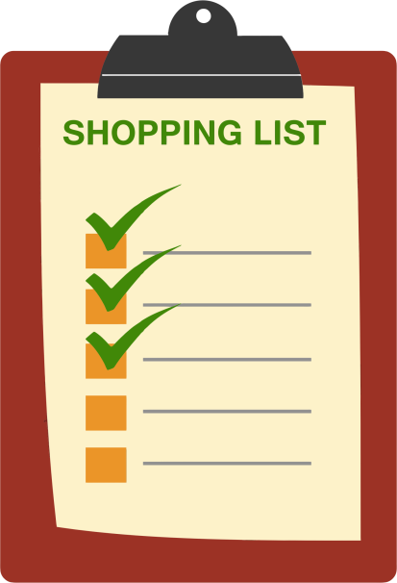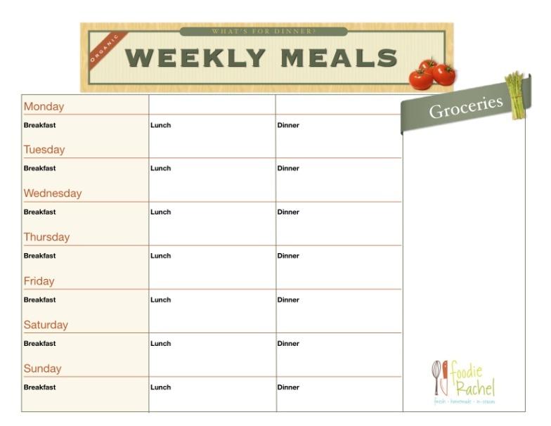

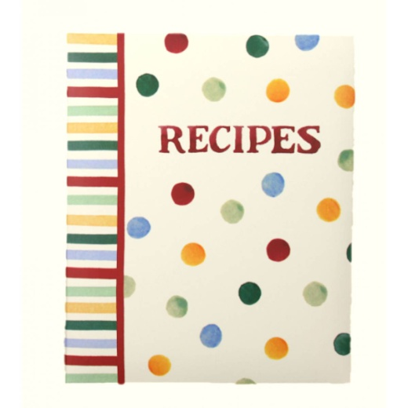
I love to look through recipe books to pick out my meals.

I know that I can't eat the same amount of food and the same types of food as most other people.
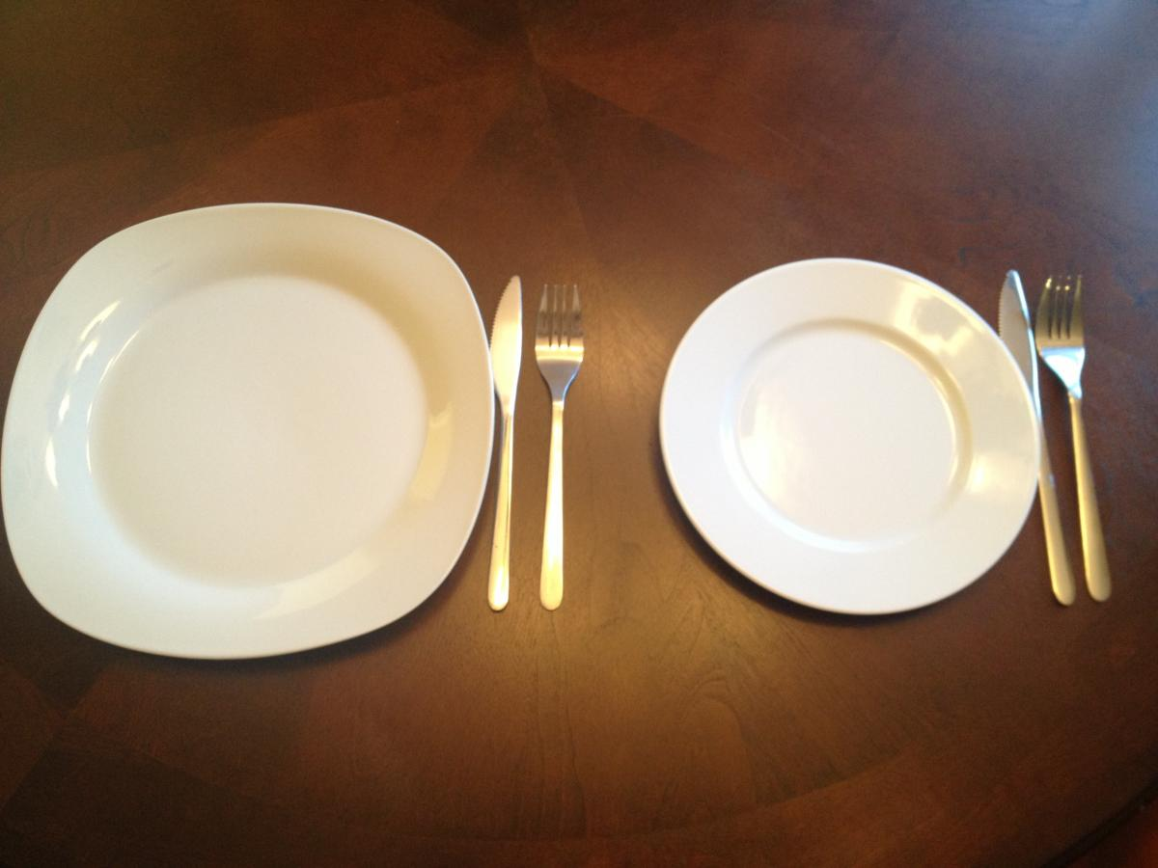

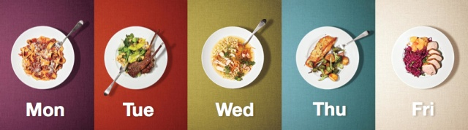
It is important to me to see what meals I am having during the week before I go shopping.

This helps me plan for any special events or meals I might need to include in my week.

Before shopping I need to be reminded and agree to what is expected of me when out:

I will go to the bathroom when we first get to
the shopping centre.
I will hold the shopping list and cross off the
items as we buy them.
I will not add food or drink to the shopping
trolley that is not on the list.
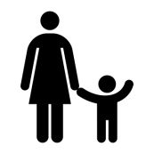
I will stay with mum and not run away.

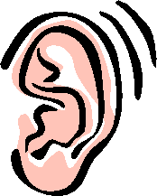
I will listen and do as I am asked.
When shopping is finished I can go for [insert treat].

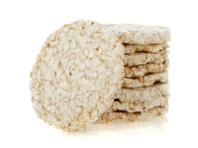
I will pack my rice crackers to snack on if I get hungry.
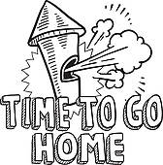
If I don't do what is expected:
We will leave the shops and come home.
This will make mum unhappy with me and I'll be sad missing out.

I will miss out on my [insert treat] at the shops.

If I need to go to the bathroom during the shopping, mum will come with me and then we can go back and finish shopping.

If I get lost I need to meet mum at the front counter of [insert grocery store name].
Sometimes shopping is hard for me.

All the food I like can be distracting.
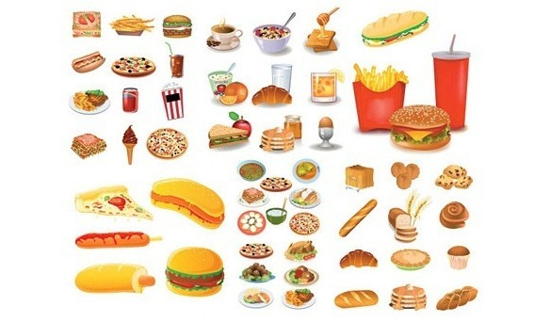
It is important that I can see my weekly meal plan.
This reminds me that I am having a lot of the food I like throughout the week and I'm not missing out.
Sometimes I might get angry and not listen.
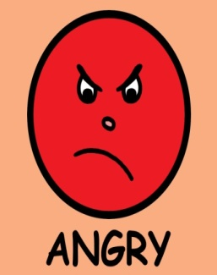
If I don't calm down or get very anxious, I might have to leave and go home.

First try to tell me that:

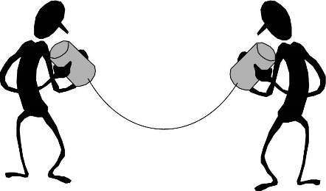
You understand and can see I am unhappy - I like to feel listened to.

Ask what I think is unfair - Maybe we can talk through it.

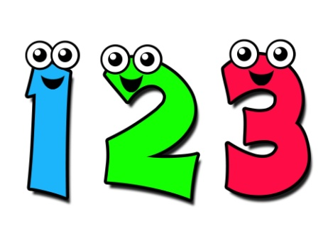
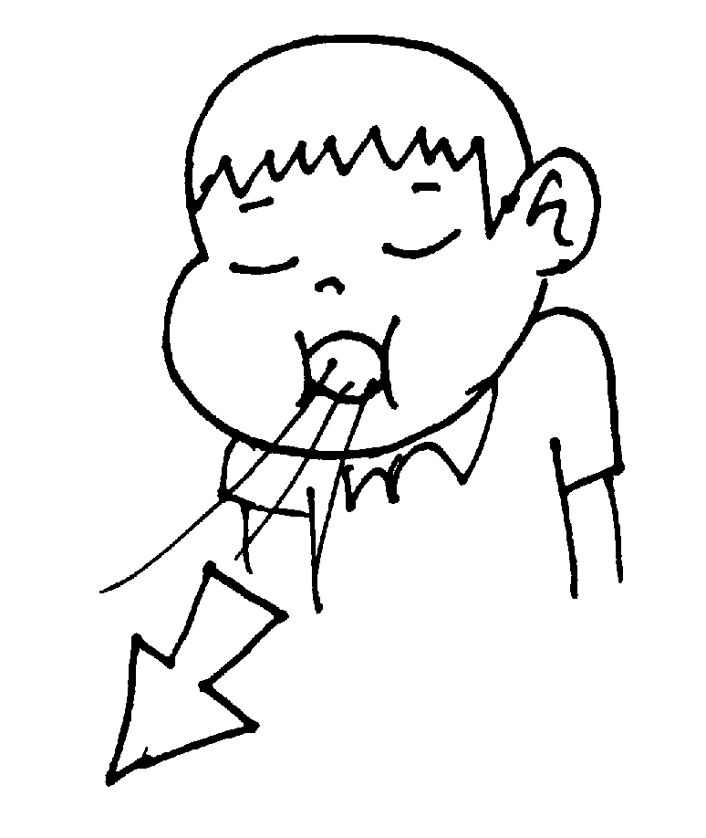
Ask me to take three deep breaths to explain what is wrong - I like to know you care and want to help.

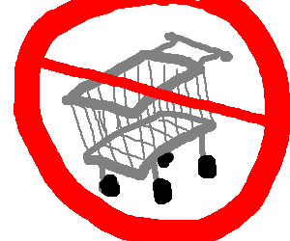
Remind me that if I don't listen and help now, we need to go home and the shopping won't get done.

Remind me that after shopping we have a lovely [insert treat].

When we have finished shopping, I like to know that I did a great job!

