MY SKIN ROUTINE

[Insert your photo here]

Every morning I need to have a shower and dry my skin well.

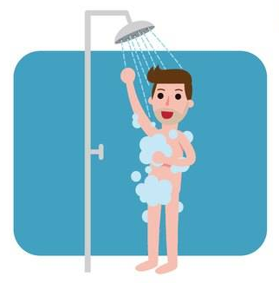

I need to moisturise my skin to keep it looking nice and healthy.

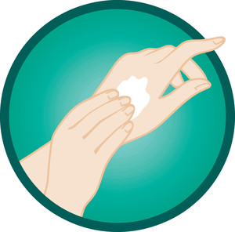
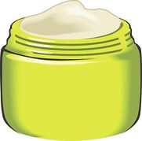

I may have sores on my body from picking that need to be checked.
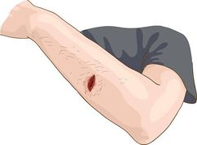

My sores might need to be covered with bandaids,
gauze or bandages.

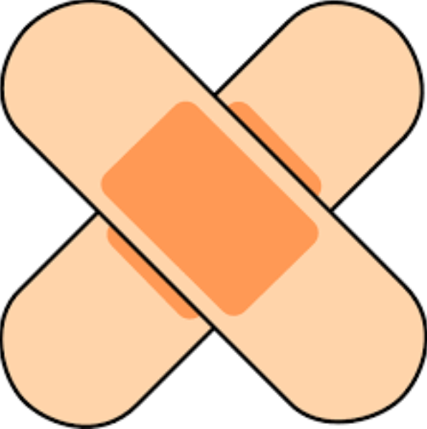

This is to help me keep them clean and to keep me safe.

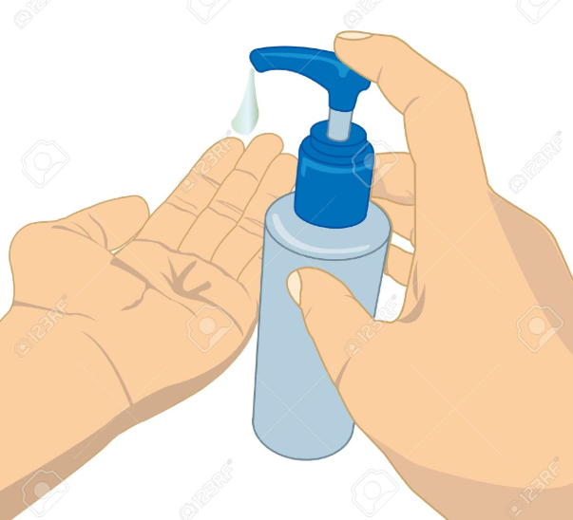
If the sores are bad, I will need a cream from the doctor
to stop them from getting infected.

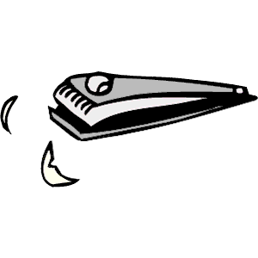
I need to have my nails checked and keep them trimmed
so that I can't scratch my skin badly.

If I work hard and don't pick my skin, it will look nice and healthy. Everyone will tell me how great I look.

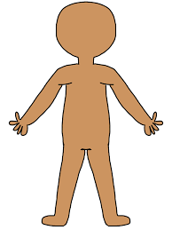

This will make me happy.

