MY SWIMMING ROUTINE

[insert photo]

I go swimming at [insert details].
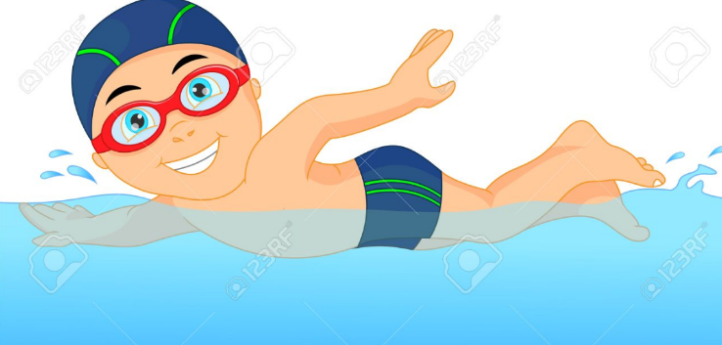

I swim every [insert swimming days].

I love swimming....

Swimming is great exercise and it keeps me healthy. Swimming is lots of fun.

Before going to swimming I need to....
Pack a towel

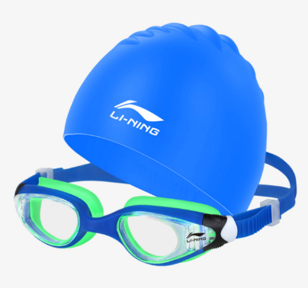
Pack goggles and
swimming cap

Pack dry clothes

Pack my water and my lunch

Before getting in the water, I need to let the person caring for me check my skin for any sores.

If I have sores, these need to be covered up with bandaids or bandages.

This is to help keep them clean and make sure I don't get an infection.

It is important that everyone listens and follows the rules at the pools.

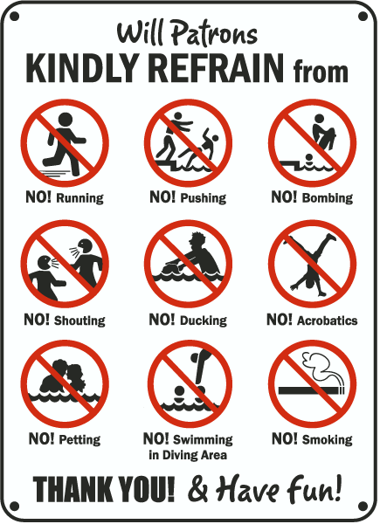

If I do not listen, or follow the rules, the pool staff can ask me to get out of the pool and leave.

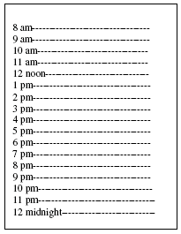
When it is [insert time] that means it is time for me to get out of the water.

When I am finished swimming I need to

Dry off

Have a shower

Put on my clean clothes

Once I am clean, dry and dressed I can have my lunch.

If I listen and have fun swimming my family will be proud of me, and I will have had a great time!

