MY SLEEP MACHINE

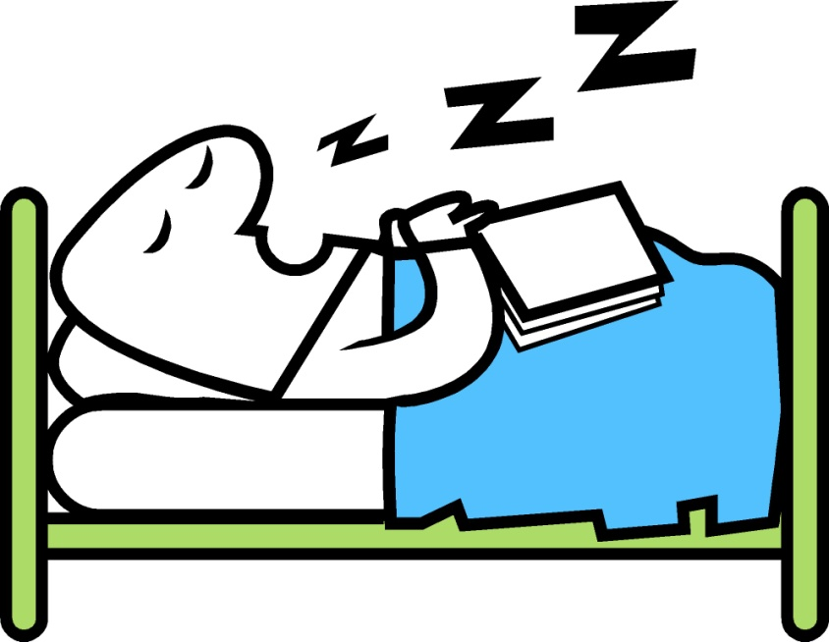

It is very important to sleep well at night

My family want to help me make sure I
sleep well at night

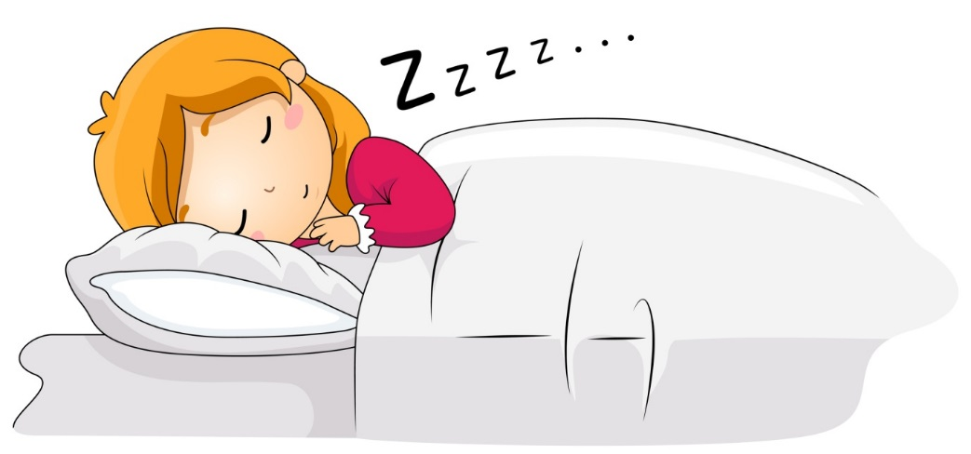

If I do not sleep well at night I will be tired

I might fall asleep at school or at work
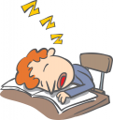

I need to have my special machine in my room,
beside my bed

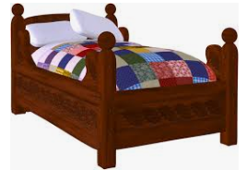
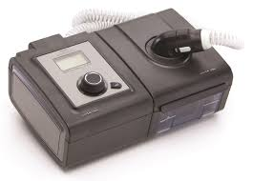

I also need to wear my special mask at night. This mask helps me breathe

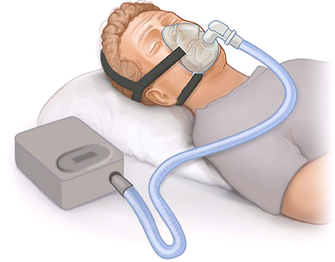

If I wear my mask all night I will feel
good in the morning

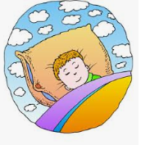

I will have lots of energy to do the things I like

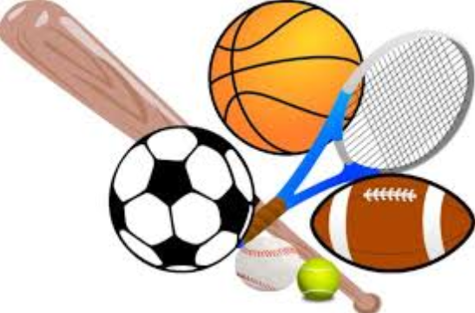

If I use my sleep machine, and wear my mask all night my family will be very proud of me!

